 | Quick Details
• | Date: 3/4/2022
• | Time: 7:00 PM
• | Church:  Cornerstone Baptist  Church 10701 E 56th St.  Indianapolis, IN 46235
• | Competition:  Bible Quiz  Psalm 37
• | Activity after Service:  Volleyball Tournament  & Pizza. COST- $7
• | Next Rally: 4/1/2022
If you have a teen group that is interested in singing a
special during this rally
season, please let us know!
We are always looking for ways to get the teens involved in the rallies!
MARCH RALLY DETAILS
I sure hope you enjoyed the snow and extra time to work on your verses for Bible Quiz.
This month our rally will be at Cornerstone Baptist Church in Indianapolis with Pastor Burton Gates as our guest speaker. This rally we will be having a Bible Quiz on Psalm 37. Even though we are nearing the end of our rally season, if you are interested in Bible quiz, come and join us to see what its all about and try it out for yourself. This month we will be having an activity as well. After the service, we are having a volleyball tournament and pizza. The cost is $7 per person. Also, I’d like to encourage all of you to invite a friend and have a chance to win a $50 gift card!
Our April rally will be held at Lighthouse Baptist Church and Pastor Jason Jett will be our guest speaker. We will be having a Bible Quiz in April as well.
We hope to see you there! Special Note:
Our rallies are financially promoted by our offerings and the extra money left over from our activities. To help us afford great preachers, over the cost of traveling, and love offering, we would like to encourage Youth Pastors, and any other groups coming, to get each of their teenagers to give an offering. If every person who came just gave $1, it would greatly help provide for the cost of our rallies. Thank you in advance for your giving heart.

We like to encourage our teenagers to dress for the occasion. Attached you will find our dress code.

Questions or Concerns?
If you have any questions or concerns, please feel free to contact
Byrl Murdock at 765.650.1445 or byrlmurdock@lbcministries.org.
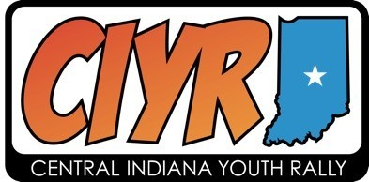
For more information about the CIYR, please visit ciyr.org.

